Magic Invitational Report: Chris Pikula
Chris Pikula
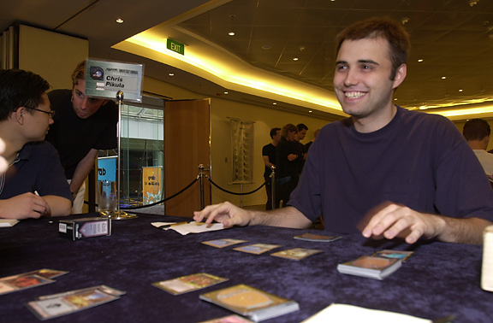
Most people probably look forward to a free trip to Australia to hang out with their friends and play cards. Not me. I had a number of reasons to fear the trip:
- I was the reigning Invitational Champion after winning in Kuala Lumpur, and I wasn't too happy about the likely scenario of me losing the crown.
- I had to pay $1400 for Dave "The Hump" Humphery's ticket due to "The Deal" from last year.
- I had to be on a plane for 20 or so hours each way with Jon Finkel. There are two places you don't want to see Finkel: sitting across from the table from you at a Pro Tourney, and sitting next to you on a really long flight.
The first two on the list were unavoidable, they were going to happen whether I went to Australia (affectionately known to IRCers as .au) or not. So I decided I'd brave the journey with Finkel and participate in my fourth Invitational.

Australians are decades ahead of the rest of the world in bathroom related technology.
Because I'm an old grumpy working man now, I didn't have any extra time to spend in Australia. This meant I would leave New York City (Brooklyn, NY is the only city with 2 participants in this year's Invitational, myself and Alex Shvartsman. You get Zvi if you take all the boroughs of NYC as being one city, but why would Alex and I want to be grouped with Zvi? We left on Sunday, got to Sydney on Tuesday morning, left the following Monday, and get back to New York Monday night. Being unfamiliar with concepts such as "time zones" and "duty-free merchandise," I was skeptical when the airline presented me with this schedule. Luckily, it worked out in the end.
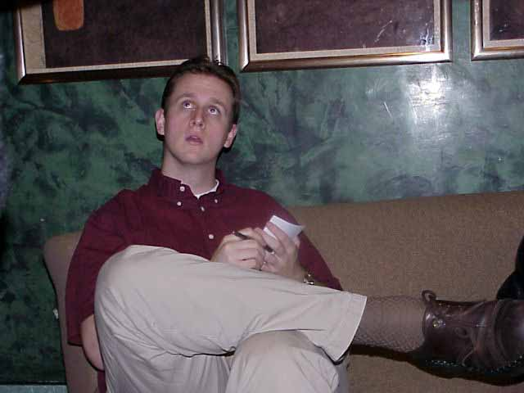
TGO?
I was pretty ill by the time I got to airport to leave, so for me the whole journey to Sydney was fairly uneventful. I slept a ton and felt miserable when I was awake. I watched Erin Brockovitch. Jon and Bob Maher (The Great One, known from now on as TGO) played some Magic; I don't even remember which format. This was nothing like the trip to Malaysia last year. That flight was good times all around; there was lots of socializing, we each had our own little video screen, and the desserts with the meals were much tastier. I felt absolutely destroyed by the time we finally landed and got through all the customs mumbo-jumbo.
The hotel this year was the Star City Casino; a casino is certainly a fine place for a group of Magic players to live for a week. Unfortunately for me, there is no poker at Star City, so my gambling for the week would only include some purely recreational blackjacking. I was rooming with David Price as usual. The hotel was very nice, and I was very pleased with the room (although again it wasn't as nice as last year). The bathroom mirror was very fancy! It cleared itself after you took a hot shower. Australians are decades ahead of the rest of the world in bathroom related technology.
Tuesday night featured the annual "Mandatory Meeting." This year's was especially exciting because it featured the unveiling of Meddling Mage, the card I designed after winning last year's tourney. The Meddling Mage is a rather good looking fellow, I suggest that when you cast him you name "Hot Chicks," or else the Mage will simply be too busy to attack. After the meeting some of us went to dinner with Mark Rosewater and I had my first encounter with some creatures I'd learn to fear over the next few days. Prawns.
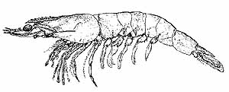
Australians love prawns! Breakfast prawns, lunch prawns, spicy prawns, hot prawns, chocolate prawns, prawns, prawns, prawns. I'm not talking about just a prawn or two either. Piles of prawns, buckets of prawns, mountains of prawns. I'm not sure I can completely convey the feeling of having those bouncy prawny eyeballs all around you, but it is very disturbing.
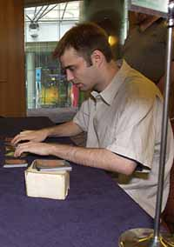
A sleepy Pikula
I could go on about prawns for a long time, but instead I'll just skip to Wednesday. Wednesday was tour day. I remember nothing of this day except standing in the rain getting my picture taken. There may have been an opera house involved. I think that Wednesday was also the day we first decided to have a birthday party. It wasn't actually anyone's birthday, but it was a great way to justify having cake and ice cream at every meal. TGO, Dave Price and myself each had a number of birthdays on the trip. Jon abstained claiming he was "trying to eat healthy."
Due to the fact I was ill the whole trip my memory is very hazy (I found out when I got back that my girlfriend had mono...), I think I'll divide the rest of the report into tourney happenings and external happenings. Trying to keep things in chronological order is simply too tricky.

The Tourney
As you probably know by now, I didn't win this year. I would have to attribute this to poor play, poor preparation, and a complete inability to Solomon Draft. Here is the format recap:
Duplicate Sealed (Predicted finish: 3-0 or 2-1 Actual Finish: 2-1): This worked out as expected, and although my loss to Jon involved some poor draws. He built his deck very well and I can't complain. Once again Mark Rosewater came through with a great format.
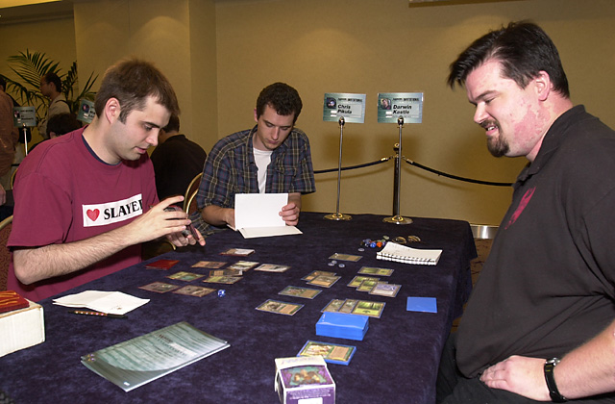
Playing Kastle, the master of Survival decks
Build Your Own Block: (Predicted Finish: 2-1 or 1-2 Actual Finish: 1-2) I played a suboptimal Survival deck ( I forgot Lhurgoyf at the last second) and probably deserved my 1-2 finish. Noah did Apocalypse me out, which was very depressing.
Solomon Draft (Predicted Finish:0-3 Actual Finish: 0-3) I'm not good.
Auction of the Champions (Predicted Finish: 2-1 or 1-2 Actual Finish: 2-1) I think I got a very good deal with Maher's deck, but my starting life total hurt me badly in my match against Ben with Dave Price's deck. I really beat Long and Zvi badly though.
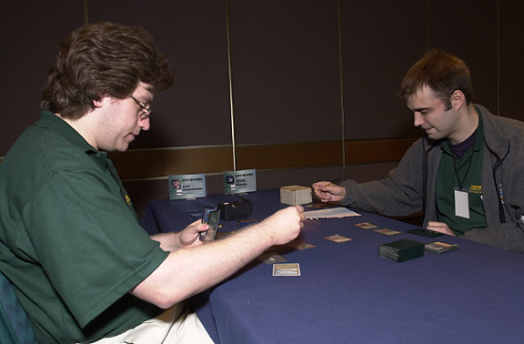
Classic (Predicted Finish: 2-1 or 3-0 Actual Finish: 2-1) I played a deck very different than anyone else in the tourney, and I went 2-1 in some poor matchups. Negators aren't that good against Bolts and Pups. My games against Alex were particularly fun, you can check out the details in the Sideboard coverage.
So, I guess I finished 10th or so, not a great finish. At the Invitational, 2nd through 15th is pretty much a tie, so 10th isn't so bad. In a few months, nobody will remember how I did.

Extracurricular Activities
The following events may or may not have happened:
- I ate more tiramisu in one week than most men eat in one year.
- Ben Rubin ordered 12 Shirley Temples in one meal.
- The Ben Seck took us to a "club" that he "had been to before" which ended up being a brothel.
- We immediately left the previously mentioned brothel.
- Darwin Kastle pondered the possibility that he had never lost a game with his 4 Mindstone, 4 Jayemdae Tome Classic deck.
- Dave Humpherys had a leech fall off his leg and onto my hotel room floor
.
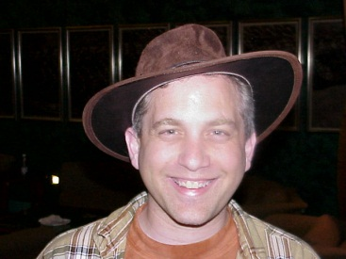
- Randy Buehler put in seven bets on the river with the third best boat up against a straight flush.
- Mark Rosewater wore some sort of Crocodile Dundee type hat the entire week.
- Out of the goodness of his heart, Mike Long bought the whole tourney hot chocolates when we were forced to play in a freezing room.
- Trevor Blackwell brought back more than half a dozen girls to his hotel room at the same time one night.
- We were given more than one opportunity to eat prawn chips.
- It rained every single day.
- Kai Budde was forced to watch the scenes in Gladiator where German barbarians get wrecked more than once.
- Ben Rubin was nearly destroyed after being peer pressured into smoking a cigar.
- Jon Finkel spent more than one day dressed as a sailor who had just got out of the brig.
- Liam Coltman repeatedly requested that I show him the "hip motion."
Anything else that may or may not happened must not have been that interesting.
I want to thank everyone who has voted for me for the Invitational in the past, and I hope you'll do so in the future. I've tried my best to respond to emails and on irc and icq to whatever questions people have, and I'll continue to do so. Feel free to keep sending emails or whatever. Let's try to keep me in the Invitational for life!

